Drug Use Among Different Social Classes
Vedrana Marinkovic
AC0906060
PS490 Research Studies
Assignment 6 06
May 14, 2017

Introduction
The use of drugs has become rampant in the past few years, particularly among the youths. The usage varies depending on several factors such as gender, age, and place of availability of the drug. Several studies have been conducted in connection with the topic of drug and drug abuse. Most studies have focused on the types of drugs commonly used and by what group, or in which part of the world. Studies have in fact shown that the usage cuts across the social class. However, it remains unclear which among the social class uses drugs the most. This study, therefore, aimed to determine who between the rich and the poor uses drugs especially crack cocaine the most.
It is a common belief that the drug usage is high among those of lower social class. This study was conducted to test the hypothesis that the poor people use drugs more than the rich people. The type of correlation expected between the use of drugs and the social class system was a negative one. For example, it is believed that the higher the social class, the lesser the drug usage, and vice versa. The expectation was as a result of the general belief that the poor people are always idle and influence one another in whatever they do. The study, therefore, went ahead to investigate the relationship between cocaine usage and a person's social class.
Sample population
Interviewees from different social classes were included in the survey. A total of 10833 respondents were interviewed where they were asked whether they have ever used crack cocaine (GSS, 2014). More specifically, the respondents were asked: Have you ever used crack cocaine? The interviewees were required to give yes or no answers. 566 respondents indicated they had used the drug while 10267 had not. The respondents were also asked to indicate their income which the study used to group them into categories. The breakdown of the respondents according to their earnings category is shown in the table below.
 | EVCRACK (Ever used crack cocaine)
Income of the respondent | Yes | No | total
<$1000 | 23 | 234 | 256
$1000-$2999 | 16 | 362 | 377
$3000- $3999 | 17 | 220 | 237
$4000- $4999 | 6 | 183 | 189
$5000- $5999 | 13 | 181 | 194
$6000- $6999 | 5 | 184 | 189
$7000- $7999 | 13 | 161 | 174
$8000-$9999 | 22 | 257 | 280
$10000- $14999 | 78 | 919 | 997
$15000- $19999 | 61 | 753 | 813
$20000- $24999 | 49 | 1001 | 1049
>$25000 | 264 | 5814 | 6078
Total | 566 | 10267 | 10833
Source: (GSS, 2014).
Analysis variables
The variables of the study were income and crack cocaine usage. The variable ever used was classified as a nominal with a variable name EVCRACK (GSS, 2014). Income, on the other hand, was an ordinal variable, coded with the name RINCOME. The table below gives the variables that were used in the analysis and their description.

Variable Name | Variable description (label) | Level of measurement
EVCRACK | Have ever used crack cocaine  Yes  No | Nominal
RINCOME | Respondent’s income  <$1000  $1000-$2999  $3000- $3999  $4000- $4999  $5000- $5999  $6000- $6999  $7000- $7999  $8000-$9999  $10000- $14999  $15000- $19999  $20000- $24999  >$25000 | Ordinal

Study design
Two hypotheses were tested from the data based on the respondent’s income and usage of the drug. These hypotheses were stated as;
H₀: there is no significant difference in the use of crack cocaine between the rich and the poor. (H₀: rich drug use = poor drug use)
H₁: the difference in the use of crack cocaine between the rich and the poor is significant. (H₁: rich drug use ≠ poor drug use)
H₀: there is no relationship between income and the use of crack cocaine.
H₁: there is an association between income and the use of crack cocaine
Since the variables of the study were either ordinal or nominal, statistical methods were limited to chi-square, correlation, and descriptive statistics. The study used the simple random sample. The study used SPSS to do the analysis where respondent’s income was the predictor variable. The response variable was the use of crack cocaine. This choice was made due to the researcher’s belief that somebody’s social class was a factor in him or her using the drug. The study expected to find that most poor people have used the drug compared to the rich.
Results
Statistical analysis
Have ever used crack cocaine
 |  | Frequency | Percent | Valid Percent | Cumulative Percent
Valid | No | 10266 | 94.8 | 94.8 | 94.8
Valid | Yes | 567 | 5.2 | 5.2 | 100.0
Valid | Total | 10833 | 100.0 | 100.0
94.8% of the respondents interviewed have never used crack cocaine. Only 5.2% of the respondents have ever used the drug. This can be graphically presented as shown below.
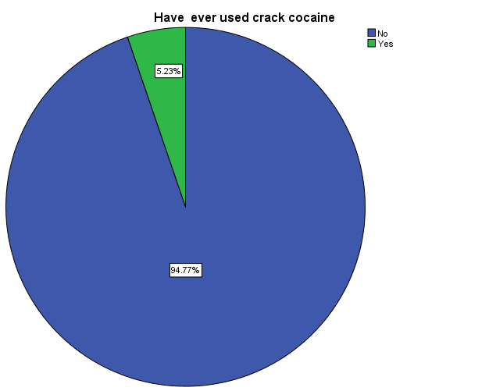
Hypothesis 1: there is no significant difference in the use of crack cocaine between the rich and the poor. (H₀: rich drug use = poor drug use)
Chi-Square Tests
 | Value | df | Asymp. Sig. (2-sided)
Pearson Chi-Square | 52.845ª | 11 | .000
Likelihood Ratio | 49.467 | 11 | .000
Linear-by-Linear Association | 10.290 | 1 | .001
N of Valid Cases | 10833

Based on the chi-square analysis, the p-value (0.00) < α (0.05) hence we reject the null hypothesis and accept the alternative. Having known that there is a difference in the drug usage between the two groups, we now check if there is a relationship between income and the drug usage.
Hypothesis 2: there is no relationship between income and the use of crack cocaine
Symmetric Measures
 |  | Value | Asymp. Std. Errorª | Approx. T^{b} | Approx. Sig.
Interval by Interval | Pearson's R | -.031 | .010 | -3.209 | .001^{c}
Ordinal by Ordinal | Spearman Correlation | -.045 | .010 | -4.712 | .000^{c}
N of Valid Cases |  | 10833

Both Pearson and Spearman’s correlations indicate p-values (0.01 and 0.00 respectively) which are all less than α (0.05). We, therefore, reject the null hypothesis and accept the alternative that there exists a relationship between respondent's income and drug usage. The next step is to determine who, between the poor and the rich uses the drugs more than the other.
Correlations
 |  | Have ever used crack cocaine | Respondent’s income
Have ever used crack cocaine | Pearson Correlation | 1 | -.031**
Have ever used crack cocaine | Sig. (2-tailed) |  | .001
Have ever used crack cocaine | N | 10833 | 10833
Respondent’s income | Pearson Correlation | -.031** | 1
Respondent’s income | Sig. (2-tailed) | .001
Respondent’s income | N | 10833 | 10833
**. Correlation is significant at the 0.01 level (2-tailed).

From the Pearson correlation analysis, there is a weak correlation of -0.031. The weak negative correlation is an indication that those with higher income use crack cocaine less than those with lower earnings.
Findings and discussion
The overall aim of this research analysis was to determine who between the high-income earners and the low-income earners are prone to the use of crack cocaine. The study wanted to determine the truth behind the common belief that the poor use the drug more than the wealthy. Using data from General Social Survey, the analysis focused on income and the drug usage. The analysis yielded the following results; the rich and the poor use the drug at different rates, there is a relationship between the income of the respondent and drug usage, and that the poor use the drug more than the rich. These findings were consistent with the previous assumption that the poor use the drug more than the wealthy.
The results proved that the existing pieces of literature are right in their prediction that the drug usage is high among the low-income earners than among the high-income earners. The study also realized that the number of people who use crack cocaine are only 5.23%, contrary to what was expected.
Recommendation
Although the study managed to prove that the poor use the drug more than the rich, the reason for their high use is not yet determined. This study, therefore, recommends further research to be conducted to determine the real reason why the poor use crack cocaine more than the rich.
Reference
GSS,. (2014). GSS Data Explorer | NORC at the University of Chicago. Gssdataexplorer.norc.org. Retrieved 25 April 2016, from https://gssdataexplorer.norc.org/variables/5072/vshow

